Netcode for unity research

The concept of synchronisation is involved when creating a multiplayer game, making them more complex to develop than single player games. Everything within the multiplayer game needs to run smoothly to achieve a harmonious shared reality.

Unity provides Netcode for GameObjects for multiplayer functionality. It is a first party, mid level networking library targeted towards small scale, multiplayer games. The Netcode handles communication and networking between clients and the server to create a synchronised environment.

Multiplayer games work through the communication between clients and servers. The clients and servers send and receive packets over the network. This is called a transport. The transport allows for a shared reality to be created between players who connect to a multiplayer server. Gameplay such as moving a character is then synchronised to other clients when data packets are sent to them.

The netcode library (see figure 1) abstracts the sending of packets away from gameplay code with features such as networked variable and Remote Procedure Calls (RPC). [1]

There are two netcode packages: the pre-release Netcode for GameObjects and the experimental Netcode for Entities. I will be using Netcode for GameObjects for my game.

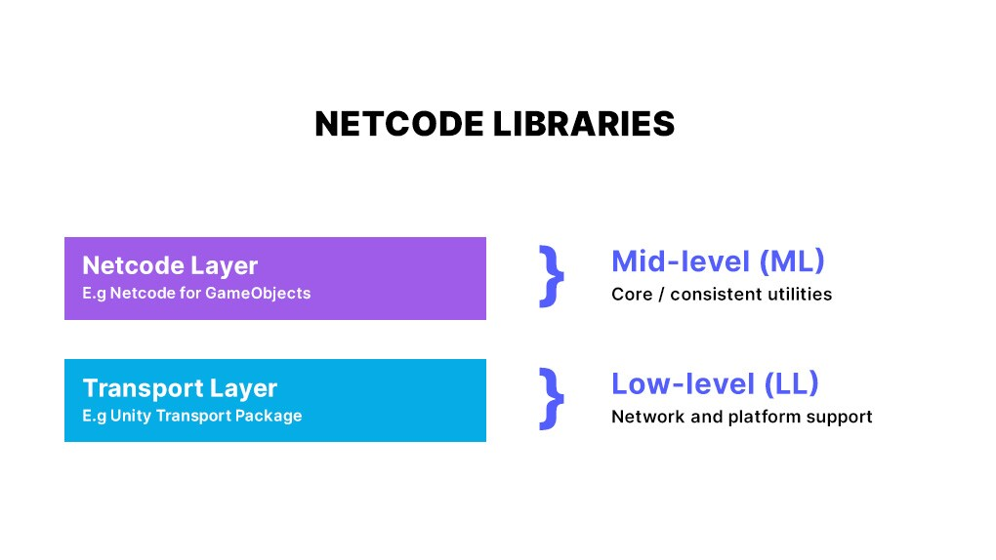

Figure - Netcode Libraries

It is advised to implement the features of a multiplayer game as early as possible. This is recommended because features of multiplayer games need to be synchronised across the server. Features of a game need to be explored at the beginning of development to ensure they are compatible with a multiplayer environment.

A common misconception in multiplayer game development is that low latency provides the best gameplay experience.[1] However, gameplay where states are synchronised to ensure a consistent shared reality is vital. A smooth gaming experience is not always a benefit of low latency.

[1] <https://blog.unity.com/games/netcode-facts-fiction>

[2] <https://blog.unity.com/games/the-8-factors-of-multiplayer-gamedev-in-small-scale-cooperative-games-ft-breakwaters>